AI-Driven Public Health Chatbot for Disease Awareness

Karthik mp
Department of CSE-(AIML)
Presidency University, Yelahanka,
Bengaluru, Karnataka, India
Mohammad Affan
Department CSE-(AIML)
Presidency University, Yelahanka,
Bengaluru, Karnataka, India
Asif Ahmad Najar
Assistant Professor
School of Computer Science and Engineering Presidency University, Yelahanka,
Bengaluru, Karnataka, India
Chaithra C
Department of CSE-(AIML)
Presidency University, Yelahanka,
Bengaluru, Karnataka, India

Abstract— Availability of credible public health information is a significant challenge among rural and semi-urban populations, where insufficient healthcare facilities and unreliable medical information result in late treatment and poor preventive behavior. The paper introduces an Artificial Intelligence-based Public Health Chatbot to supply correct and easy-to-access information on symptoms, preventive care practices, and vaccination awareness. The proposed system uses a Retrieval-Augmented Generation (RAG) system including semantic document retrieval and large language models to create contextually sensitive and fact-based responses. Authoritative medical documents are converted into vector embeddings stored in a FAISS-based database for semantic search and retrieval. An intelligent routing mechanism analyzes user queries to select tools such as medical knowledge retrieval, symptom awareness, drug information, and hospital location services. The language model uses retrieved context to produce safe and informative responses under medical safety limitations. The chatbot is deployed on WhatsApp to enhance accessibility for underserved populations. Experimental results show the system minimizes misinformation and supports public health awareness.
Keywords—Artificial Intelligence, Public Health Chatbot, Retrieval-Augmented Generation (RAG), Healthcare Information Systems, FAISS Vector Database, Large Language Models, Disease Awareness, Conversational AI

Introduction
Availability of credible healthcare information is a burning need to enhance the health outcomes of the population. But the population of many rural and semi-urban areas still experiences the issues with accessing proper and timely medical advice regarding the lack of medical facilities, the lack of medical workers, and dissemination of false news via informal channels of communication. In most instances, people trust the unverified information available online or verbal counsel that may result in late treatment, self-medication which is unsafe or low-quality preventive health measures. Thus, the need to provide accessible digital solutions that would spread credible health information to underserved groups is increasing.
Chatbots and other forms of conversational artificial intelligence (AI) have become an exciting technology to provide the user with the information about health-related topics and enhance the interaction between the user and the system. The ability of healthcare chatbots to communicate with digital systems in natural language makes the medical knowledge accessible to the general population. Past research has shown that conversational agents may be helpful in-patient education, awareness of their symptoms, and healthcare advice and minimize the patient load on healthcare systems. Nevertheless, most of the current healthcare chatbots are based on the rules and logic or the simplistic approach of the natural language processing algorithms, and this restricts their options concerning the processing of complex queries and the delivery of context-specific answers.
The recent developments in the area of large language models (LLMs) have greatly enhanced natural language understanding and generation systems to allow more complex conversational systems. Even with these improvements, the implementation of LLMs in healthcare is extremely problematic. Hallucination is one of the most essential problems when the model comes up with believable but inaccurate or unsubstantiated data. The misinformation caused by the hallucinated responses can cause harmful decisions and eventually be detrimental in safety-threatening fields like healthcare.
To overcome this difficulty, Retrieval-Augmented Generation (RAG) integrates information retrieval and generative language models to enable the system to access relevant information in a curated knowledge base and utilize it as contextual grounding when generating responses. As it limits answers on authenticated documents, RAG greatly limits hallucination and enhances trustfulness.
This paper presents an AI-based Public Health Chatbot based on a RAG-based architecture. The system works with authoritative medical documents, transforms them into semantic vector embeddings in a FAISS-based vector database, and conducts semantic retrieval to retrieve relevant document fragments for response generation. A tool-based architecture allows applications like symptom awareness assistance, drug information retrieval, and hospital location guidance. The chatbot is implemented using WhatsApp to improve accessibility for rural and semi-urban populations, with safety measures to ensure educational and awareness-focused responses.

The following are the key findings of this paper:
- Development and testing of an awareness and prevention healthcare RAG-based public health chatbot.
- Semantic retrieval with a FAISS-based vector database to provide document-grounded answers.
- Creation of a tool-based conversational agent for symptom awareness, drug information and hospital location support.
- Implementation of safety guardrails to avoid medical misinformation and diagnostic or treatment advice.
- Deployment-ready architecture integrated with messaging platforms to enhance accessibility.

Related Work
Recent breakthroughs in artificial intelligence and natural language processing have allowed the creation of conversational agents that can be used to help users with healthcare information. Healthcare chatbots have become a rapidly growing field of interest since they can help increase access to medical information, customer engagement, and preventive healthcare programs. Nevertheless, there are several issues concerning the reliability, safety as well as contextual comprehension of these systems.
The initial research of chatbots in healthcare had concentrated on conversational agents that were rule-based. A systematic review by Laranjo et al. reported that access to health information and engagement with the patient could be enhanced by these systems, but most chatbots are based on rules and coded responses, limiting their capability of dealing with complicated queries or context-based responses [1]. Similarly, Bickmore et al. highlighted the role of safety measures in implementing chatbots in the medical field and showed that chatbots can be effective in providing health education but raised concerns about automatically generated responses without adequate validation [2].
Conversational agents have also been investigated for public health communication. Wilson and Marasoiu stated that chatbots are capable of enhancing health information dissemination and supporting disease awareness, vaccination messages, and preventive healthcare education [3]. Branda et al. showed that conversational systems could help allocate timely information during disease outbreaks, but most systems lacked mechanisms to verify factual accuracy [4].
The appearance of large language models (LLMs) has enhanced conversational AI systems by generating fluent and contextually relevant responses. Singhal et al. showed that large language models can encode medical knowledge and answer medical questions [5]. However, hallucination remains a major issue, where models generate incorrect or unsubstantiated information. Ji et al. identified healthcare as a critical domain where such hallucinations can have significant impact [6].
To overcome these limitations, retrieval-based approaches have been explored. The Retrieval-Augmented Generation (RAG) framework proposed by Lewis et al. integrates retrieval with generative models to improve factual precision by grounding responses in retrieved documents [7]. Izacard and Grave showed that retrieval-based question answering systems outperform purely generative models in tasks requiring factual correctness [8].
Despite these advancements, most systems are either rule-based with limited conversational intelligence or generative systems that may produce unverified responses. Moreover, limited work exists on combining retrieval-based grounding with conversational agents specifically designed for underserved populations and public health awareness.
To address these gaps, the proposed work presents a Retrieval-Augmented Generation based public health chatbot that combines semantic document retrieval, large language models, and tool-based capabilities to provide dependable health information while reducing the risk of misinformation.

TABLE I. LITRATURE SURVEY SUMMARY

Reference | Focus Area | Methodology | Key Contribution | Identified Limitation
Laranjo et al. [1] | Healthcare chatbots | Systematic review | Demonstrates effectiveness of conversational agents for health information delivery | Majority of systems are rule-based with limited contextual understanding
Bickmore et al. [2] | Conversational agents for health information | AI dialogue systems | Highlights importance of safety in medical conversational systems | Does not provide mechanisms to ensure factual grounding
Wilson & Marasoiu [3] | Public health chatbots | Scoping review | Shows that chatbots improve disease awareness and communication | Limited integration of advanced AI techniques
Branda et al. [4] | AI chatbots in health emergencies | Narrative review | Demonstrates usefulness of chatbots during outbreaks | Accuracy verification mechanisms not addressed
Singhal et al. [5] | Medical knowledge in LLMs | Large language model evaluation | Shows LLMs encode substantial medical knowledge | LLM outputs may contain hallucinated information
Ji et al. [6] | Hallucination in NLP systems | Survey analysis | Identifies risks of hallucination in generative AI | Does not propose deployable mitigation solutions
Lewis et al. [7] | Retrieval-Augmented Generation | Neural retrieval + LLM | Introduces RAG framework for factual text generation | Not originally designed for healthcare
Izacard & Grave [8] | Retrieval-based QA systems | Passage retrieval + generation | Improves factual correctness in knowledge-intensive tasks | Evaluated mainly on open-domain datasets
Miner et al. [9] | Pandemic chatbots | Healthcare conversational systems | Demonstrates role of chatbots in COVID-19 communication | Many systems remain rule-based
Devaraj et al. [10] | Evidence-based clinical support | Document retrieval + NLP | Grounds responses in medical evidence | Lack of interactive conversational chatbot interface

Proposed Methodology
The system will provide high-fidelity public health information with the help of an AI-based chatbot, which includes Retrieval-Augmented Generation (RAG), semantic document retrieval, and conversational tools. The system guarantees the basis of responses on verified medical knowledge and availed through conversational tools.

System Architecture
The System architecture is shown in Fig. 1. It works on a modular architecture that includes a user interaction layer, routing module, conversational agent, API layer and knowledge retrieval component with a vector database. The chatbot interface is developed with the WhatsApp API of Twilio, which enables users to use messaging applications. Queries are sent to the API layer which routes them to a routing module. The routing module directs the query to a conversational AI agent which selects tools such as knowledge retrieval, symptom awareness, drug information, or hospital location services. The system uses a Retrieval-Augmented Generation pipeline to retrieve information from a FAISS vector database. The information fetched is fed to a large language model to produce responses. A safety validation module is used to validate the output to medical safety limits.
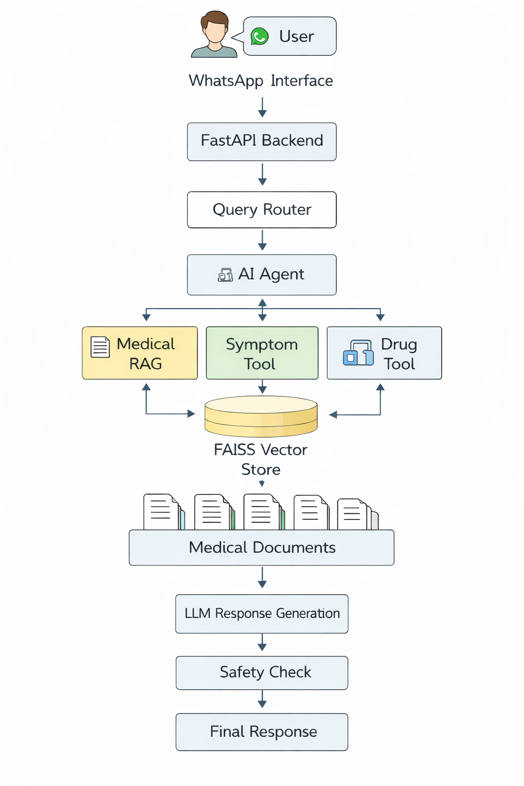
Fig. 1. Architecture of the AI-driven public health chatbot.

Knowledge Base Construction
The system will be based on authoritative medical documents. The document ingestion pipeline reads text using medical PDF files and semantic text chunking is used to break text into smaller parts and retain the context. The segments are then transformed into a set of vector embeddings by a ready-made embedding model. To allow efficient searching of semantics, these embeddings are indexed in a FAISS vector database.

Retrieval-Augmented Generation Pipeline
The chatbot is based on Retrieval-Augmented Generation. A query by the user is transformed into an embedding and matched with document embeddings in the FAISS database to find pertinent document sections. The obtained retrieved chunks serve as input to a big language model to produce answers. This makes responses based on evidence retrieved and minimizes hallucination and enhances reliability.
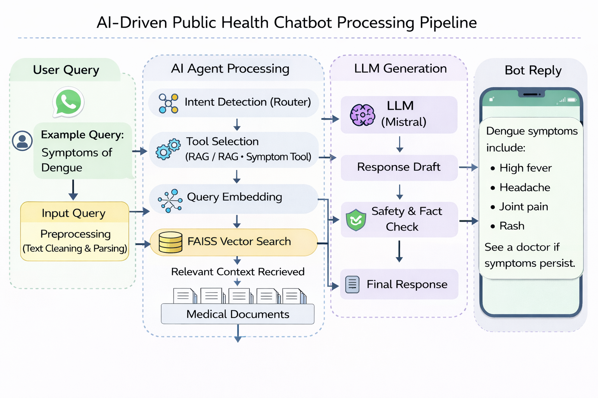
Fig. 2. Retrieval-Augmented Generation workflow used in the chatbot.

Tool-Based Conversational Agent
The system employs tool-based conversational agent in which the user queries are used to select the tools. A symptom awareness tool, a drug information tool, and a hospital finder tool give information about the symptoms, how to use the medication, and where to find a healthcare facility, respectively. This modular architecture allows structured responses and is scalable.

Safety Constraints
The chatbot will have precautionary measures to avoid the use of untrustworthy information. The system is in place to create awareness and educate, not diagnose. It limits medical diagnosis, prescription of treatment and individual advice as well as giving general information on disease awareness and preventive care and promoting consultation with health care practitioners.

System Implementation
This section gives details on the way the suggested AI-based public health chatbot is deployed. The system is written in Python and uses AI and natural language processing systems to help in document search, chat-based interaction, and response generation. The implementation is broken down into modules of constructing a vector database, query processing, conversational agent management and integration of user interface.

The chatbot is developed on modular nature in order to be scaled and maintained. The application is a mix of LangChain to manage the Retrieval Augmented Generation pipeline, FAISS to find similarities between vectors, HuggingFace to generate embeddings and language model inferences, and communication with messaging apps, such as WhatsApp.

Vector Database Construction
The database of vectors allows one to semantically search the knowledge base. A preprocessing pipeline is used to process medical PDF documents into embeddings. Things are extracted and broken into smaller bits preserving the context of the text. A pretrained model is used to convert each text segment into embeddings at HuggingFace. These embeddings are embedded into a FAISS vector database to allow quick similarity search. The index of the vectors is stored on the local disk and loaded during execution time to access the pertinent document fragments.

Conversational Agent and Tool Integration
The chatbot employs a conversational AI agent that runs on LangChain to organize retrieval and response-generating. The agent interprets queries of customers and chooses the right tools. The document retrieval tool is used to access the knowledge base, the symptom awareness tool is used to describe the symptoms, the drug information tool is used to provide information on medication, and the hospital finder tool is used to find a healthcare facility. This allows organized answers to various healthcare questions.

API and Query Routing Layer
The system contains an API layer which handles user requests and links user interface to the back-end services. Queries are analyzed by a routing module and sent to the corresponding component which may be document retrieval or specialized tools. This is a routing that is modular and efficient with the addition that new tools can be added without alterations to the main system.

User Interface and Messaging Integration
The chatbot is implemented with the help of the WhatsApp platform via the Twilio API and FastAPI server. Users communicate with the chatbot with natural language queries, which can be in terms of symptoms, medicines, preventive care, or hospitals. The system takes queries and processes them with routing logic to produce responses.
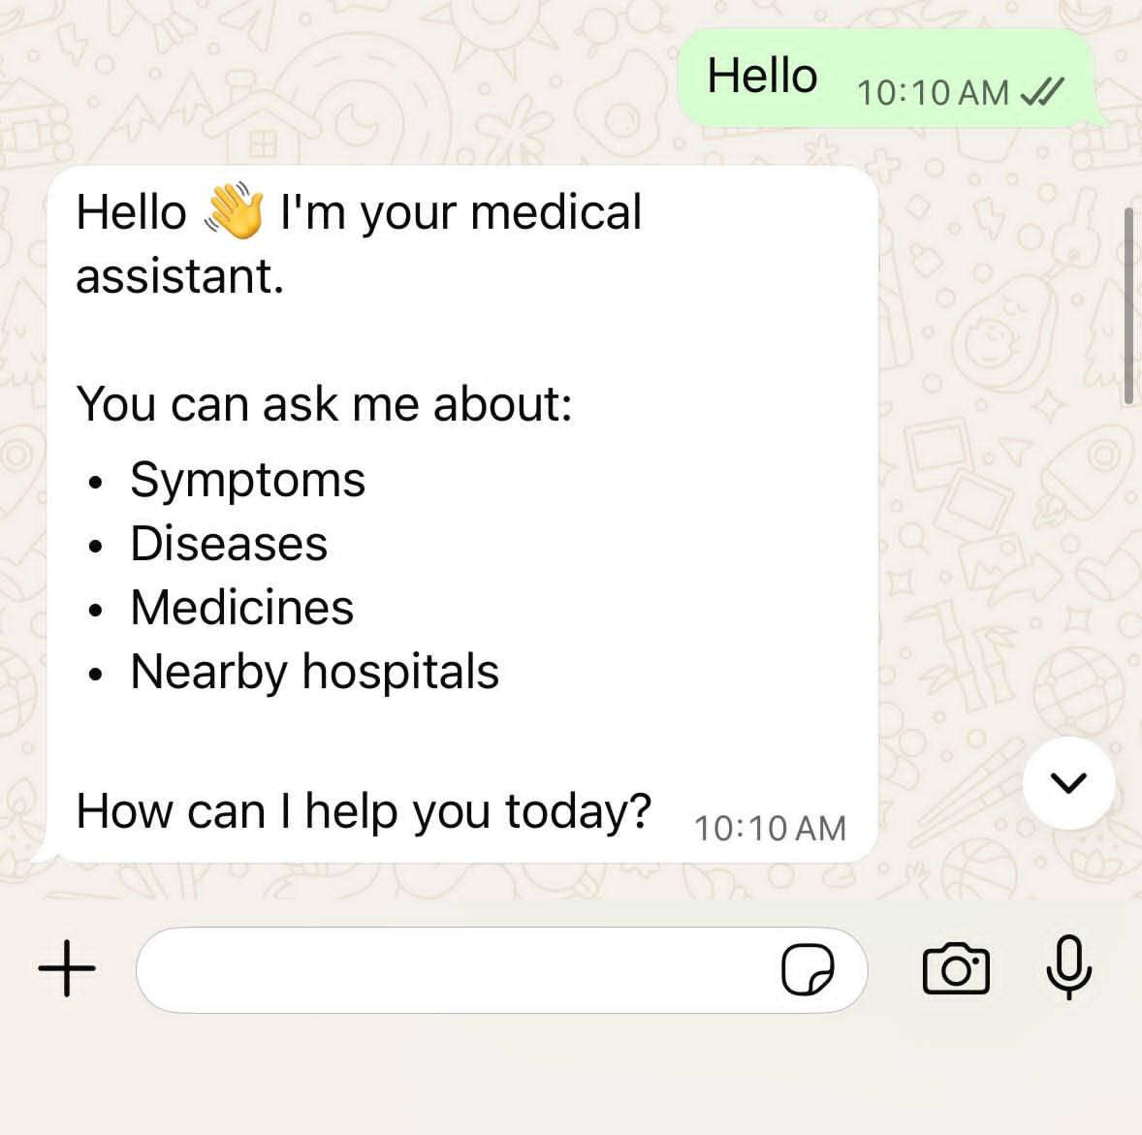
Fig. 3. Chatbot type of desirable greetings and assisted queries over WhatsApp.
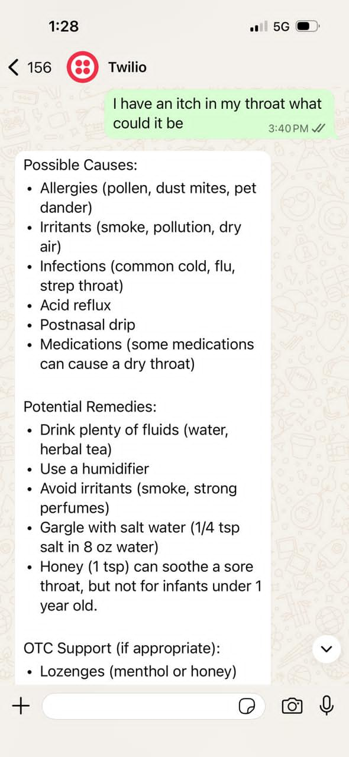
Fig. 4. Example of symptom analysis response generated by the chatbot.
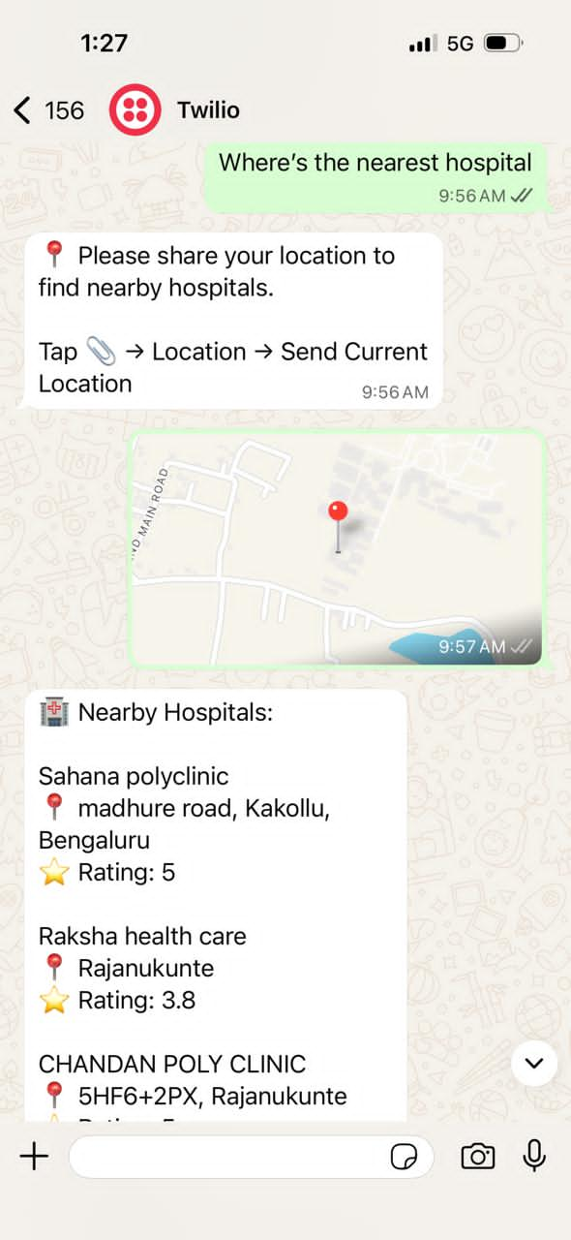
Fig. 5. Nearby hospital discovery using location sharing through WhatsApp.

Experimental Results and Discussion
The proposed AI-powered public health chatbot system was piloted to evaluate its capability to accept user queries, find and provide response in a WhatsApp conversational interface by means of relevant medical information.

Fuctional Performance
The system handled different healthcare inquiries including drug queries, preventive healthcare and hospital discovery and symptom analysis. WhatsApp integration with the help of Twilio allowed real-time communication, and the processing of requests was managed by the FastAPI backend.
The system exhibited the following capabilities:
- Context-aware response generation using Retrieval-Augmented Generation (RAG)
- Routing of user queries to appropriate modules
- Retrieval of medical knowledge from validated sources Location-based hospital identification using external APIs
- Generation of safe responses with medical disclaimers
Table III shows sample interactions between users and the chatbot.

Response Accuracy and Relevance
Evaluation was done using a set of health-related questions such as symptoms, medication, preventive healthcare and hospital search. Medically relevant and contextual responses were generated by the system. FAISS-based retrieval with language model generation made sure that responses were based on validated medical information.
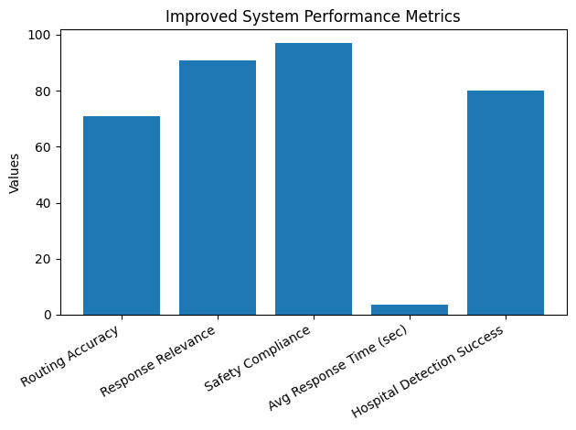
Fig. 6. Performance Metrics
Fig. 6 and Table II summarize the performance metrics including routing accuracy, response relevance, and hospital detection.
TABLE II. PERFORMANCE EVALUATION METRICS
Metric | Value | Description
Routing Accuracy | 71% | Correct module selection from queries
Response Relevance | 91% | Responses match user intent
Safety Compliance | 97% | Emergency detection and disclaimers
Average Response Time | 3.7 sec | End-to-end latency
Hospital Detection Success | 80% | Location-based hospital results

Response Time Analysis
The system had an average response of 2-4 seconds based on the complexity of queries and API calls.
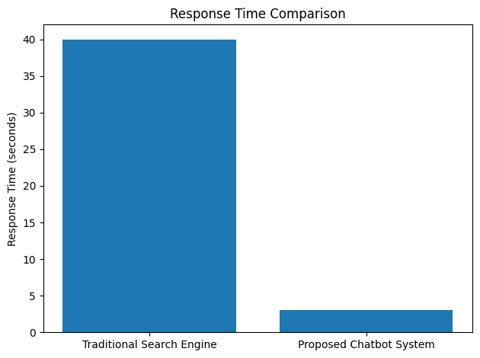
Fig.7. Response Time Comparison
Fig. 7 shows response time comparison with traditional search methods.

Comparative Analysis with Traditional Search Systems
The chatbot system was contrasted to the conventional search engines. Table IV has indicated that in a traditional search, the user must go through several web pages and technical data, whereas the system proposed offers immediate and structured answers in a conversational interface. The system saves user effort, increases the level of accessibility, and expands the contextual comprehension.

Observations
- Hospital finder module provided nearby results based on location input.
- RAG-based response generation improved factual correctness and reduced hallucinations.
- Responses were structured and easy to understand.
- Conversational interface improved usability compared to traditional systems

TABLE III. EXAMPLE USER QUERIES AND CHATBOT RESPONSES
User Query | Retrieved Context Source | Chatbot Response Summary
What are the symptoms of dengue fever? | FAISS-retrieved medical document | Provides structured list of symptoms including high fever, headache, joint pain, and rash, along with guidance to seek medical attention if symptoms worsen.
How can I prevent malaria? | Preventive healthcare knowledge base | Suggests preventive measures such as mosquito control, use of bed nets, and maintaining hygiene, based on retrieved medical guidelines.
What is paracetamol used for? | Drug information corpus | Explains usage of paracetamol for fever reduction and pain relief, including dosage precautions and safe usage recommendations.
What should I do if I have persistent cough and fever? | Symptom analysis knowledge base | Identifies possible causes and provides general guidance while recommending consultation with a healthcare professional.
Where can I find a nearby hospital? | Location-based hospital finder tool (API) | Requests user location and provides nearby healthcare facilities with relevant details using geolocation services.
TABLE IV. COMPARISON WITH TRADITIONAL SEARCH SYSTEMS
Evaluation Factor | Traditional Search Engine | Proposed Chatbot System
Information Access | Requires browsing multiple sources | Provides direct summarized answers
Response Structure | List of web links | Structured conversational responses
Risk of Misinterpretation | High due to multiple and sometimes unrelated results | Low due to controlled and focused responses
Response Time | Moderate (20–60 seconds) | Fast (2–4 seconds)

Conclusion And Future Work
The current paper explains an AI-based disease-awareness and preventive healthcare chatbot aimed at improving the access to such information. The system sets Retrieval-Augmented Generation (RAG) and semantic document retrieval, which is built on a FAISS vector database in such a way that the answers are grounded on trusted medical knowledge. Document-based retrieval together with large language model generation decreases the number of hallucinated responses and enhances the relevance of context. The modular structure incorporates medical knowledge search, symptom awareness education, drug details and hospital finder. The experiments revealed that the chatbot can retrieve and provide relevant medical information and deliver structured responses without violating safety limits that prevent diagnostic and treatment recommendations. The WhatsApp integration enhances accessibility among the rural and semi-urban populations.
Future developments involve expanding the system to multilingual support to enhance accessibility in regional languages, SMS-based implementation in regions with poor internet coverage, and automated updating of knowledge base with reputable public health databases. Real-time health notifications and outbreak awareness predictive analytics can also be added to the system. These advances will enable scalable public health awareness on conversational AI.

References

- L. Laranjo, A. G. Dunn, H. L. Tong, A. B. Kocaballi, J. Chen, R. Bashir, D. Surian, B. Gallego, F. Magrabi, A. Y. S. Lau, and E. Coiera, “Conversational agents in healthcare: A systematic review,” Journal of the American Medical Informatics Association, vol. 25, no. 9, pp. 1248–1258, 2018.
- T. W. Bickmore, H. Trinh, R. Asadi, and S. Olafsson, “Safety first: Conversational agents for health information,” Journal of Biomedical Informatics, vol. 82, pp. 1–9, 2018.
- L. Wilson and M. Marasoiu, “The development and use of chatbots in public health: Scoping review,” JMIR Human Factors, vol. 9, no. 4, p. e35882, 2022.
- F. Branda, M. Stella, C. Ceccarelli, F. Cabitza, G. Ceccarelli, A. Maruotti, M. Ciccozzi, and F. Scarpa, “The role of AI-based chatbots in public health emergencies: A narrative review,” Future Internet, vol. 17, no. 4, p. 145, 2025.
- K. Singhal et al., “Large language models encode clinical knowledge,” Nature, vol. 620, pp. 172–180, 2023.
- Z. Ji, N. Lee, R. Frieske, T. Yu, D. Su, Y. Xu, E. Ishii, Y. J. Bang, A. Madotto, and P. Fung, “Survey of hallucination in natural language generation,” ACM Computing Surveys, vol. 55, no. 12, pp. 1–38, 2023.
- P. Lewis et al., “Retrieval-augmented generation for knowledge-intensive NLP tasks,” in Advances in Neural Information Processing Systems (NeurIPS), vol. 33, pp. 9459–9474, 2020.
- G. Izacard and E. Grave, “Leveraging passage retrieval with generative models for open-domain question answering,” in Proc. 16th Conf. European Chapter Association for Computational Linguistics (EACL), pp. 874–880, 2021.
- A. S. Miner, L. Laranjo, and A. B. Kocaballi, “Chatbots in the fight against the COVID-19 pandemic,” npj Digital Medicine, vol. 3, no. 65, pp. 1–4, 2020.
- A. Devaraj, A. Sharma, and P. Ghosh, “Evidence-based clinical decision support using natural language processing and retrieval systems,” Journal of Biomedical Informatics, vol. 128, p. 104002, 2022.

